Activity 08
Risk identification and analysis
2025-2026
Note: Be sure to include all group member's names in your submission.

Scenario: Estimating a TravelTech Marketplace SaaS Platform
Your team has been contracted to build a TravelTech Marketplace SaaS platform that connects travel agencies, tour operators, and individual travelers. The system will allow users to:
- Discover and book curated travel experiences
- Compare prices and itineraries across providers
- Manage bookings, payments, and reviews
- Access personalized recommendations based on preferences and location
- Integrate with third-party APIs (e.g., Google Maps, Stripe, Amadeus)
The platform must be scalable, multi-tenant, and support both web and mobile interfaces.

Project Characteristics
Attribute | Details
Estimated Size | 95 KLOC
Project Type | Embedded (high complexity, tight constraints, diverse team)
Development Team | 12 developers, 3 QA engineers, 1 DevOps, 1 PM
Timeline Expectation | 14–18 months
Constraints | Must support multi-currency, multi-language (Arabic, English, French), and comply with GDPR and AML laws
Technology Stack | Node.js (backend), React Native (mobile), PostgreSQL, Docker, Kubernetes
Deployment Model | SaaS with subscription tiers for agencies and operators + commissions on sales

COCOMO Constants:
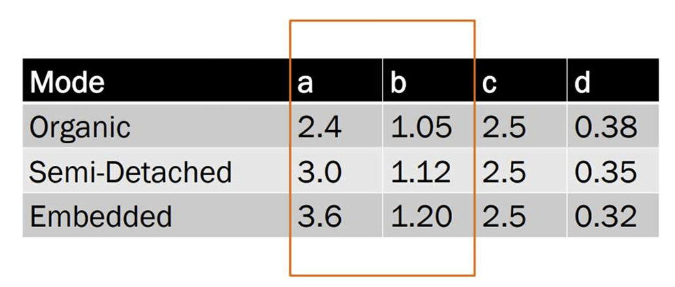

Student Tasks
- Effort Estimation
  - Use the Basic COCOMO formula to estimate effort in person-months
- Development Time
  - Estimate the development time in months
- Team Size
  - Calculate the average team size
- Analysis & Discussion
  - Compare your results with the client’s expectations.
  - Discuss how changing the project type (Semi-detached to embedded or the opposite) would affect the estimates.
  - Reflect on the limitations of Basic COCOMO and how Intermediate COCOMO could improve accuracy.

Intermediate COCOMO:
- Introduce cost drivers from Intermediate COCOMO:

 | Ratings
 | Very Low | Low | Nominal | High | Very High | Extra High
Product attributes
Required software reliability | 0.75 | 0.88 | 1.00 | 1.15 | 1.40
Size of application database |  | 0.94 | 1.00 | 1.08 | 1.16
Complexity of the product | 0.70 | 0.85 | 1.00 | 1.15 | 1.30 | 1.65
Hardware attributes
Run-time performance constraints |  |  | 1.00 | 1.11 | 1.30 | 1.66
Memory constraints |  |  | 1.00 | 1.06 | 1.21 | 1.56
Volatility of the production environment (servers) |  | 0.87 | 1.00 | 1.15 | 1.30
Required turnabout time |  | 0.87 | 1.00 | 1.07 | 1.15
Personnel attributes
Analyst capability | 1.46 | 1.19 | 1.00 | 0.86 | 0.71
Applications experience | 1.29 | 1.13 | 1.00 | 0.91 | 0.82
Software engineer capability | 1.42 | 1.17 | 1.00 | 0.86 | 0.70
Production environment experience ( servers technology) | 1.21 | 1.10 | 1.00 | 0.90
Programming language experience | 1.14 | 1.07 | 1.00 | 0.95
Project attributes
Application of software engineering methods | 1.24 | 1.10 | 1.00 | 0.91 | 0.82
Use of software tools | 1.24 | 1.10 | 1.00 | 0.91 | 0.83
Required development schedule | 1.23 | 1.08 | 1.00 | 1.04 | 1.10

- Adjust your estimates based on selected drivers and justify your choices.

Submission
Be sure to include all group members' names in your submission.

